https://www.kaggle.com/datasets/mrayushagrawal/us-crime-dataset

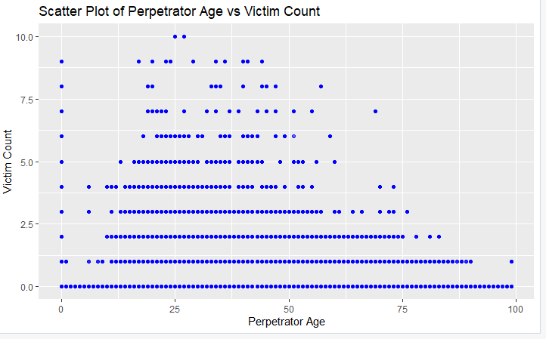

• **Purpose**: The scatter plot visualizes the relationship between the age of perpetrators and the number of victims involved in the incidents.

• **Analysis**:

* Each point on the graph represents an individual incident, where the x-axis corresponds to the perpetrator's age and the y-axis to the number of victims.
* If points are widely dispersed across the plot, it indicates no clear correlation between perpetrator age and victim count.
* Clusters of points in specific areas might suggest patterns, such as certain age groups being more likely to have a higher or lower victim count.
* If a line pattern appears (positive or negative), it could indicate a trend where victim count increases or decreases with the perpetrator's age.
* **Outliers**: Any points far removed from the rest of the data might indicate unusual cases, such as very young or old perpetrators with an exceptionally high number of victims.

